UNIFIED MODELING LANGUAGE

Introduction
The unified modeling language (UML) is a standard language for writing software blue prints.
The UML is a language for
  - Visualizing
  - Specifying
  - Constructing
  - Documenting
The artifacts of a software system:
UML is a language that provides vocabulary and the rules for combing words in that vocabulary for the purpose of communication.
A modeling language is a language whose vocabulary and rules focus on the concept and physical representation of a system. Vocabulary and rules of a language tell us how to create and real well formed models, but they don‘t tell you what model you should create and when should create them.
Visualizing
The UML is more than just a bunch of graphical symbols. In UML each symbol has well defined semantics. In this manner one developer can write a model in the UML and another developer or even another tool can interpret the model unambiguously.

SPECIFYING
UML is used for specifying means building models that are precise, unambiguous and complete. UML addresses the specification of all the important analysis, design and implementation decisions that must be made in developing and deploying a software intensive system.
Constructing :
UML is not a visual programming language but its models can be directly connected to a variety of programming languages. This means that it is possible to map from a model in the UML to a programming language such as java, c++ or Visual Basic or even to tables in a relational database or the persistent store of an object-oriented database. This mapping permits forward engineering. The generation of code from a UML model into a programming language. The reverse engineering is also possible you can reconstruct a model from an implementation back into the UML.
Documenting
UML is a language for Documenting. A software organization produces all sorts of artifacts in addition to raw executable code. These artifacts include Requirements, Architecture, Design, Source code, Project plans, Test, Prototype, and Release. Such artifacts are not only the deliverables of a project, they are also critical in controlling, measuring and communicating about a system during its development and after its deployment.

Conceptual model of the UML:
To understand the UML, we need to form a conceptual model of the language and this requires learning three major elements.
The UML Basic Building Blocks.
The Rules that direct how those building blocks may be put together. Some common mechanisms that apply throughout the UML. As UML describes the real time systems it is very important to make a conceptual model and then proceed gradually. Conceptual model of UML can be mastered by learning the following three major elements:

UML building blocks
Rules to connect the building blocks Common mechanisms of UML
UML building blocks. The building blocks of UML can be defined as:
  - Things
  - Relationships
  - Diagrams
Things:
Things are the most important building blocks of UML. Things can be:
  - Structural
  - Behavioral
  - Grouping
  - Annotational
Structural things:
The Structural things define the static part of the model. They represent physical a conceptual elements. Following are the brief descriptions of the structural things. Class:
Class represents set of objects having similar responsibilities.
Interface:
Interface defines a set of operations which specify the responsibility of a class
Use case:
Use case represents a set of actions performed by a system for a specific goal.
Component:
Component describes physical part of a system.
Node: A node can be defined as a physical element that exists at run time.
Behavioral things:
A behavioral thing consists of the dynamic parts of UML models. Following are the behavioral things:
Interaction:
Interaction is defined as a behavior that consists of a group of messages exchanged among elements to accomplish a specific task.
State machine:

State machine is useful when the state of an object in its life cycle is important. It defines the sequence of states an object goes through in response to events. Events are external factors responsible for state change.
Grouping things
Grouping things can be defined as a mechanism to group elements of a UML model together. There is only one grouping thing available.
Package: Package is the only one grouping thing available for gathering structural and behavioral things.
Annotational things: Annotational things can be defined as a mechanism to capture remarks, descriptions, and comments of UML model elements. Note is the only one Annotational thing available.
Note: A note is used to render comments, constraints etc of an UML element.
Relationships in UML:
Relationship is another most important building block of UML. It shows how elements are associated with each other and this association describes the functionality of an application. There are four kinds of relationships available.

Dependency:
Dependency is a relationship between two things in which change in one element also affects the other one.
Association:
Association is basically a set of links that connects elements of an UML model. It also describes how many objects are taking part in that relationship.
Generalization:
Generalization can be defined as a relationship which connects a specialized element with a generalized element. It basically describes inheritance relationship in the world of objects.
Realization:
Realization can be defined as a relationship in which two elements are connected. One element describes some responsibility which is not implemented and the other one implements them. This relationship exists in case of interfaces.
UML Diagrams:
UML diagrams are the ultimate output of the entire discussion. All the elements,
Relationships are used to make a complete UML diagram and the diagram represents a system. The visual effect of the UML diagram is the most important part of the entire process. All the other elements are used to make it a complete one.
UML includes the following nine diagrams and the details are described in the following
  - Class diagram
  - Object diagram
  - Use case diagram
  - Sequence diagram
  - Collaboration diagram

  - Activity diagram
  - Statechart diagram
  - Deployment diagram
  - Component diagram
Types of UML Diagram
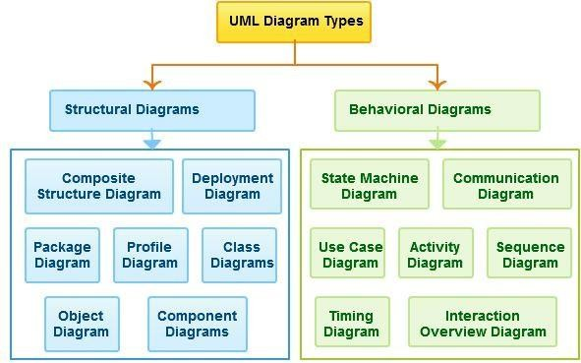

ARCHITECTURE OF UML
Any real world system is used by different users. The users can be developers, testers, business people, analysts and many more. So before designing a system the architecture is made with different perspectives in mind. The most important part is to visualize the system from different viewer‘s perspective. The better we understand the better we make the system. UML plays an important role in defining different perspectives of a system. These perspectives are:
  - Design
  - Implementation
  - Process
  - Deployment
And the centre is the Use Case view which connects all these four. A Use case represents the functionality of the system. So the other perspectives are connected with use case.
Design of a system consists of classes, interfaces and collaboration. UML provides class diagram, object diagram to support this. Implementation defines the components assembled together to make a complete physical system. UML component diagram is used to support implementation perspective.
Process defines the flow of the system. So the same elements as used in Design are also used to support this perspective.
Deployment represents the physical nodes of the system that forms the hardware. UML deployment diagram is used to support this perspective.

Automatic Teller Machine Description of ATM System
The software to be designed will control a simulated automated teller machine (ATM) having a magnetic stripe reader for reading an ATM card, a customer console (keyboard and display) for interaction with the customer, a slot for depositing envelopes, a dispenser for cash, a printer for printing customer receipts, and a key- operated switch to allow an operator to start or stop the machine. The ATM will communicate with the bank‘s computer over an appropriate communication link. (The software on the latter is not part of the requirements for this problem.)
The ATM will service one customer at a time. A customer will be required to insert an ATM card and enter a personal identification number (PIN) – both of which will be sent to the bank for validation as part of each transaction. The customer will then be able to perform one or more transactions. The card will be retained in the machine until the customer indicates that he/she desires no further transactions, at which point it will be returned – except as noted below.
The ATM must be able to provide the following services to the customer:
- A customer must be able to make a cash withdrawal from any suitable account linked to the card. Approval must be obtained from the bank before cash is dispensed.

- A customer must be able to make a deposit to any account linked to the card, consisting of cash and/or checks in an envelope. The customer will enter the amount of the deposit into the ATM, subject to manual verification when the envelope is removed from the machine by an operator. Approval must be obtained from the bank before physically accepting the envelope.
- A customer must be able to make a transfer of money between any two accounts linked to the card.
- A customer must be able to make a balance inquiry of any account linked to the card.
- A customer must be able to abort a transaction in progress by pressing the Cancel key instead of responding to a request from the machine.
The ATM will communicate each transaction to the bank and obtain verification that it was allowed by the bank. Ordinarily, a transaction will be considered complete by the bank once it has been approved. In the case of a deposit, a second message will be sent to the bank indicating that the customer has deposited the envelope. (If the customer fails to deposit the envelope within the timeout period, or presses cancel instead, no second message will be sent to the bank and the deposit will not be credited to the customer.)
If the bank determines that the customer‘s PIN is invalid, the customer will be required to re-enter the PIN before a transaction can proceed. If the customer is unable to successfully enter the PIN after three tries, the card will be permanently retained by the machine, and the customer will have to contact the bank to get it back.
If a transaction fails for any reason other than an invalid PIN, the ATM will display an explanation of the problem, and will then ask the customer whether he/she wants to do another transaction.
The ATM will provide the customer with a printed receipt for each successful transaction, showing the date, time, machine location, type of transaction, account(s), amount, and ending and available balance(s) of the affected account (―to‖ account for transfers).
The ATM will have a key-operated switch that will allow an operator to start and stop the servicing of customers. After turning the switch to the ―on‖ position, the operator will be required to verify and enter the total cash on hand. The machine can only be turned off when it is not servicing a customer. When the switch is moved to the ―off‖ position, the machine will shut down, so that the operator may remove deposit envelopes and reload the machine with cash, blank receipts, etc.

Use case diagram for ATM System.
A Use case Diagram is a diagram that shows a set of Use cases and actors and their relationships. These diagrams are used to model the static use case view of a system.
To model a system the most important aspect is to capture the dynamic behavior. To clarify a bit in details, dynamic behavior means the behavior of the system when it is running /operating. So only static behavior is not sufficient to model a system rather dynamic behavior is more important than static behavior. In UML there are five diagrams available to model dynamic nature and use case diagram is one of them. Now as we have to discuss that the use case diagram is dynamic in nature there should be some internal or external factors for making the interaction. These internal and external agents are known as actors. So use case diagrams are consists of actors, use cases and their relationships. The diagram is used to model the system/subsystem of an application. A single use case diagram captures a particular functionality of a system. So to model the entire system numbers of use case diagrams are used.
Purpose:
The purpose of use case diagram is to capture the dynamic aspect of a system. But this definition is too generic to describe the purpose. Because other four diagrams (activity, sequence, collaboration and Statechart) are also having the same purpose. So we will look into some specific purpose which will distinguish it from other four diagrams. Use case diagrams are used to gather the requirements of a system including internal and external influences. These requirements are mostly design requirements. So when a system is analyzed to gather its functionalities use cases are prepared and actors are identified.

So in brief, the purposes of use case diagrams can be as follows:
- Used to gather requirements of a system.
- Used to get an outside view of a system.
- Identify external and internal factors influencing the system.
- Show the interacting among the requirements are actors.

When to Use: Use Cases Diagrams
- Use cases are used in almost every project.
- They are helpful in exposing requirements and planning the project.
- During the initial stage of a project most use cases should be defined.

No. | Name | Notation |  |  | Description
1 | System boundary |  | 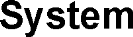 |  | The scope of a system can be represented by a system boundary. The use cases of the system are placed inside the system boundary, while the actors who interact with the system are put outside the system. The use cases in the system make up the total requirements of the system.
2 | Use case |  |  |  | A use case represents a user goal that can be achieved by accessing the system or software application.
3 | Actor | 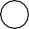 |  |  | Actors are the entities that interact with a system. Although in most cases, actors are used to represent the users of system, actors can actually be anything that needs to exchange information with the system. So an actor may be people, computer hardware, other systems, etc. Note that actor represent a role that a user can play, but not a specific user.
4 | Association |  |  |  | Actor and use case can be associated to indicate that the actor participates in that use case. Therefore, an association corresponds to a sequence of actions between the actor and use case in achieving the use case.
5 | Generalization |  |  |  | A generalization relationship is used to represent inheritance relationship between model elements of same type.
6 | Include |  |  |  | An include relationship specifies how the behavior for the inclusion use case is inserted into the behavior defined for the base use case.

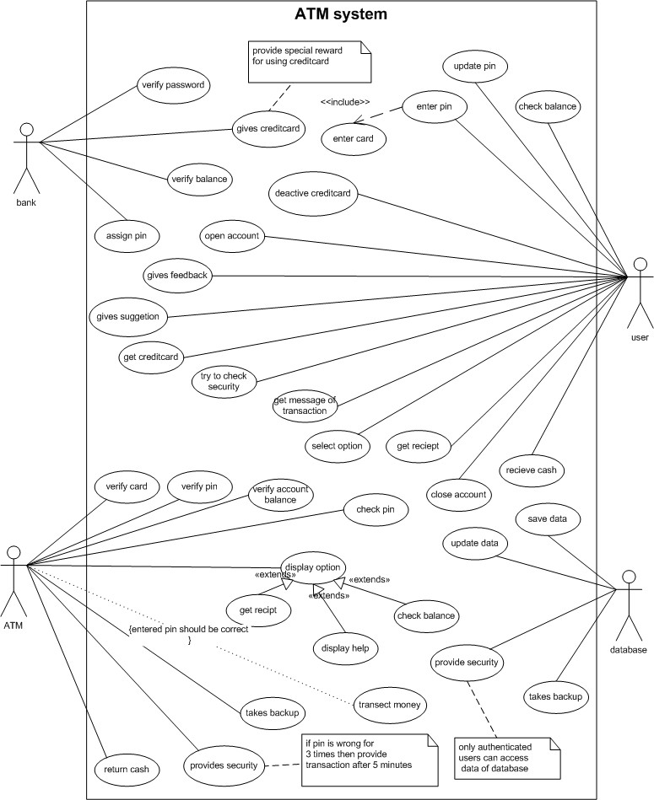
Class diagram for ATM System

The class diagram is a static diagram. It represents the static view of an application. Class diagram is not only used for visualizing, describing and documenting different aspects of a system but also for constructing executable code of the software application. The class diagram describes the attributes and operations of a class and also the constraints imposed on the system. The class diagram shows a collection of classes, interfaces, associations, collaborations and constraints. It is also known as a structural diagram.
Purpose:
The purpose of the class diagram is to model the static view of an application. The class diagrams are the only diagrams which can be directly mapped with object oriented languages and thus widely used at the time of construction. The UML diagrams like activity diagram, sequence diagram can only give the sequence flow of the application but class diagram is a bit different. So it is the most popular UML diagram in the coder community. So the purpose of the class diagram can be summarized as:
  - Analysis and design of the static view of an application.
  - Describe responsibilities of a system.
  - Base for component and deployment diagrams.
  - Forward and reverse engineering.
Contents: Class diagrams commonly contain the following things
  - Classes
  - Interfaces
  - Collaborations
  - Dependency, generalization and association relationships

When to use : Class Diagram
- Useful for Forward and Reverse engineering.
- Class diagrams are useful both for abstract modeling and for designing actual programs.
- Developer uses class diagram for implementation decision.
- Business analysts can use class diagrams to model systems from the business perspective.
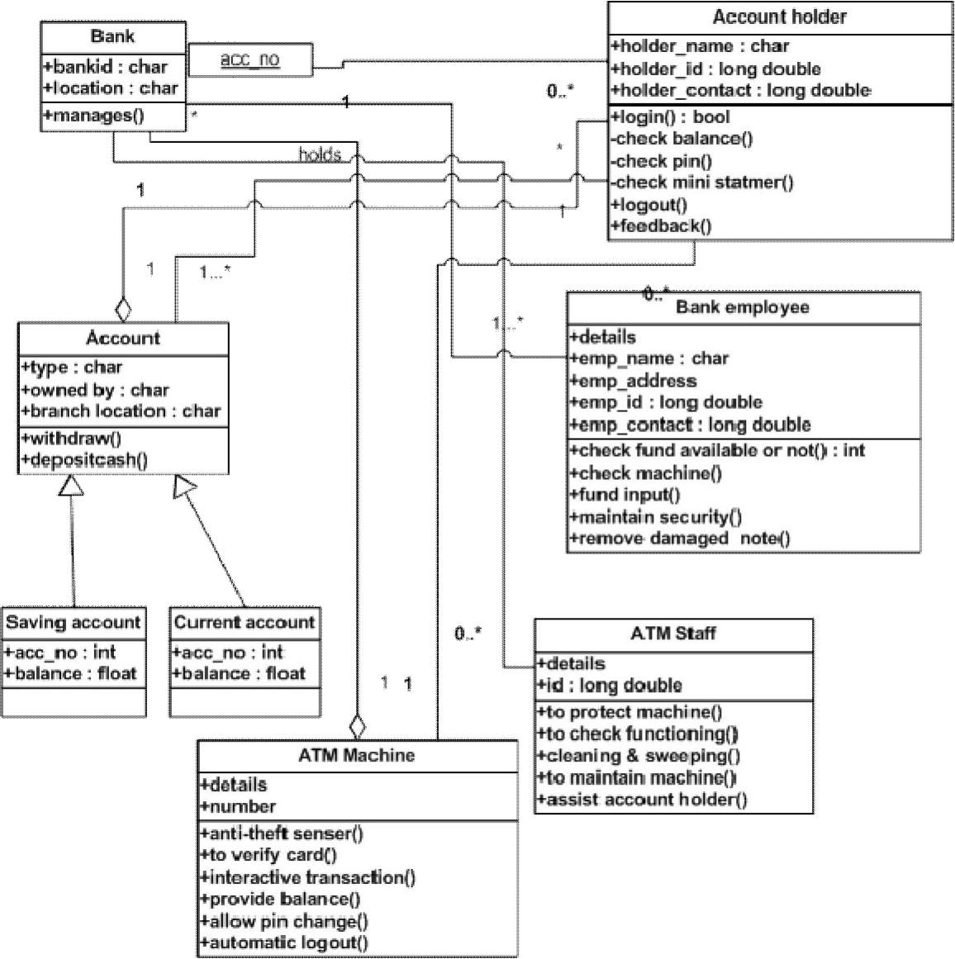

INTERACTION DIAGRAMS
We have two types of interaction diagrams in UML. One is sequence diagram and the other is a collaboration diagram. The sequence diagram captures the time sequence of message flow from one object to another and the collaboration diagram describes the organization of objects in a system taking part in the message flow.
So the following things are to identified clearly before drawing the interaction diagram:
- Objects taking part in the interaction.
- Message flows among the objects.
- The sequence in which the messages are flowing.
- Object organization.
Purpose:
- To capture dynamic behaviour of a system.
- To describe the message flow in the system.
- To describe structural organization of the objects.
- To describe interaction among objects.
Contents of a Sequence Diagram
Objects
Focus of control Messages
Life line Contents.
Contents of a Collaboration/Communication Diagram
Objects Links Messages

Sequence diagram for ATM System

A Sequence diagram is an interaction diagram that emphasizes the time ordering of messages. This diagram is used to show the dynamic view of a system.

Purpose
- The main purpose of this diagram is to represent how different business objects interact.
- A sequence diagram shows object interactions arranged in time sequence.
- It depicts the objects and classes involved in the scenario and the sequence of messages exchanged between the objects needed to carry out the functionality of the scenario.
When to use : Sequence Diagram

- Sequence diagram can be a helpful modeling tool when the dynamic behavior of objects needs to be observed in a particular use case or when there is a need for visualizing the “big picture of message flow”.
- A company’s technical staff could utilize sequence diagrams in order to document the behavior of a future system.
- It is during the design period that developers and architects utilize the diagram to showcase the system’s object interactions, thereby putting out a more fleshed out overall system design.
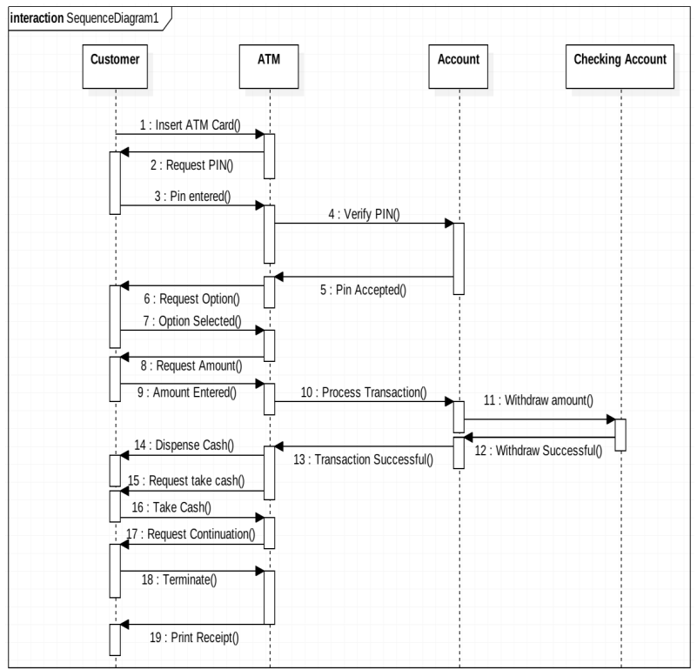

Collaboration for ATM System.

A Communication or Collaboration diagram, as shown is a directed graph that uses objects and actors as graph nodes. The focus of the collaboration diagram is on the roles of the objects as they interact to realize a system function. Directional links are used to indicate communication between objects. These links are labeled using appropriate messages. Each message is prefixed with a sequence number indicating the time ordering needed to realize the system function.

Purpose:
- Model message passing between objects or roles that deliver the functionalities of use cases and operations
- Model mechanisms within the architectural design of the system
- Capture interactions that show the passed messages between objects and roles within the collaboration scenario
- Model alternative scenarios within use cases or operations that involve the collaboration of different objects and interactions
- Support the identification of objects (hence classes), and their attributes (parameters of message) and operations (messages) that participate in use cases

- STATE CHART Diagram
Statechart diagram is used to model dynamic nature of a system. They define different states of an object during its lifetime. And these states are changed by events. So Statechart diagrams are useful to model reactive systems. Reactive systems can be defined as a system that responds to external or internal events.
Statechart diagram describes the flow of control from one state to another state. States are defined as a condition in which an object exists and it changes when some event is triggered. So the most important purpose of Statechart diagram is to model life time of an object from creation to termination.
Statechart diagrams are also used for forward and reverse engineering of a system. But the main purpose is to model reactive system.
Following are the main purposes of using Statechart diagrams:
  - To model dynamic aspect of a system.
  - To model life time of a reactive system.
  - To describe different states of an object during its life time.
  - Define a state machine to model states of an object.
Contents
Simply state and composite states Transitions, including events and actions Common use
They are use to model the dynamic aspects of a system.
Event ordered behavior of any kind of objects, to model reactive objects.
- Identify the states of the objects.
- Model the state diagram for the system.
State chart diagram for ATM System.
A Statechart diagram shows a state machine, emphazing the flow of control from state to state .A state machine is a behavior that specifies the sequences of states an object goes through during its life time in response to events together with responses to those events. We can use these diagrams to model the dynamic view of a system.

Purpose
- The state model describes those aspects of objects concerned with time and the sequencing of operations events that mark changes, states that define the context for events, and the organization of events and states.
- They are used to give an abstract description of the behavior of a system.
- It provides direction and guidance to the individual counties within the states.
- It specifies the possible states, what transitions are allowed between states.
- It describes the common behavior for the objects in a class and each object changes its behavior from one state to another.
- It is used to describe the dependence of the functionality on the state of the system that is how the functionality of an object depends on its state and how its state changes as a result of the events that it receives.
- It describes dynamic behavior of the objects of the system.
When to use: State Diagram
- They are perfectly useful to model behavior in real time system.
- Each state represents a named condition during the life of an object during which it satisfies some condition or waits for some event.
- It determines how objects of that class react to events.
- For each object state, it determines what actions the object will perform when it receives an event.

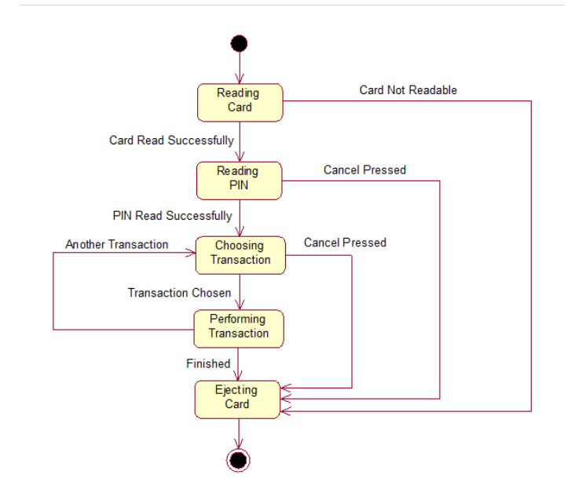

Activity diagram for ATM System.
An activity diagram shows the flow from activity to activity .An activity is an ongoing non atomic execution within a state machine. Activities ultimately results in some action, which is made up of executable atomic computations. we can use these diagrams to model the dynamic aspects of a system.
Activity diagram is basically a flow chart to represent the flow form one activity to another. The activity can be described as an operation of the system. So the control flow is drawn from one operation to another. This flow can be sequential, branched or concurrent. Activity diagrams deals with all type of flow by using elements like fork, join etc.
Contents
Initial/Final State, Activity, Fork & Join, Branch, Swimlanes
Fork
A fork represents the splitting of a single flow of control into two or more concurrent flow of control. A fork may have one incoming transition and two or more outgoing transitions, each of which represents an independent flow of control. Below fork the activities associated with each of these path continues in parallel.
Join
A join represents the synchronization of two or more concurrent flows of control. A join may have two or more incoming transition and one outgoing transition. Above the join the activities associated with each of these paths continues in parallel.
Branching
A branch specifies alternate paths takes based on some Boolean expression Branch is represented by diamond Branch may have one incoming transition and two or more outgoing one on each outgoing transition, you place a Boolean expression shouldn‘t overlap but they should cover all possibilities.
Swimlane:
Swimlanes are useful when we model workflows of business processes to partition the activity states on an activity diagram into groups. Each group representing the business organization responsible for those activities, these groups are called Swimlanes .

Purpose
- Contrary to use case diagrams, in activity diagrams it is obvious whether actors can perform business use cases together or independently from one another.
- Activity diagrams allow you to think functionally.

When to use : Activity Diagrams
- Activity diagrams are most useful when modeling the parallel behavior of a multithreaded system or when documenting the logic of a business process.
- Because it is possible to explicitly describe parallel events, the activity diagram is well suited for the illustration of business processes, since business processes rarely occur in a linear manner and often exhibit parallelisms.
- This diagram is useful to investigate business requirements at a later stage.
- An activity diagram is drawn from a very high level. So it gives high level view of a system. This high level view is mainly for business users or any other person who is not a technical person.
- This diagram is used to model the activities which are nothing but business requirements.
- So the diagram has more impact on business understanding rather implementation details.

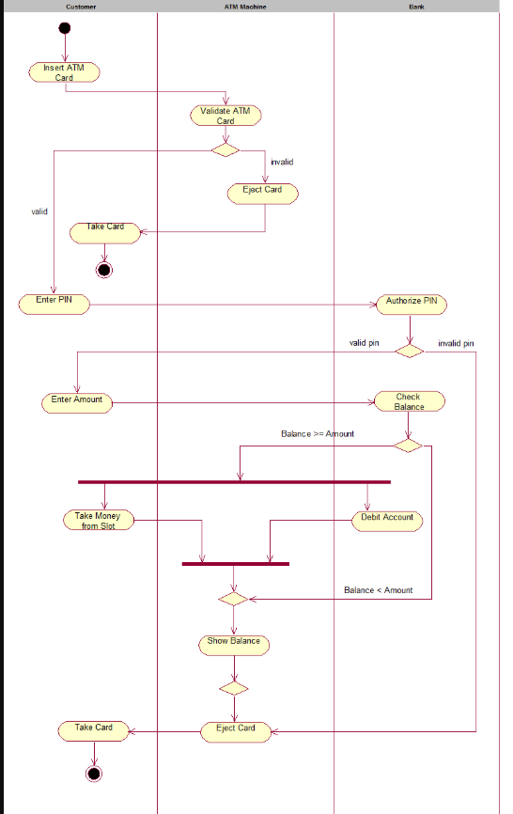
Component diagram for ATM System.
Component diagrams are used to model physical aspects of a system. Now the question is what are these physical aspects? Physical aspects are the elements like executables, libraries, files, documents etc which resides in a node. So component diagrams are used to visualize the organization and relationships among components in a system. These diagrams are also used to make executable systems.
Purpose:
Component diagrams can be described as a static implementation view of a system. Static implementation represents the organization of the components at a particular moment.
A single component diagram cannot represent the entire system but a collection of diagrams are used to represent the whole.
Before drawing a component diagram the following artifacts are to be identified clearly:
- Files used in the system.
- Libraries and other artifacts relevant to the application.
- Relationships among the artifacts.
Now after identifying the artifacts the following points needs to be followed:
- Use a meaningful name to identify the component for which the diagram is to be drawn.
- Prepare a mental layout before producing using tools.
- Use notes for clarifying important points.
Now the usage of component diagrams can be described as:
- Model the components of a system.
- Model database schema.
- Model executables of an application.
- Model system‘s source code.
Contents: Components, Interfaces, Relationships

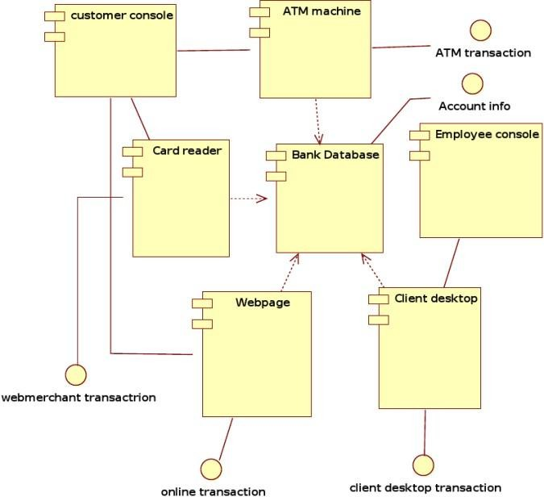

Deployment diagram for ATM System.
Deployment diagrams are used to visualize the topology of the physical components of a system where the software components are deployed. So deployment diagrams are used to describe the static deployment view of a system. Deployment diagrams consist of nodes and their relationships.
Purpose:
The name Deployment itself describes the purpose of the diagram. Deployment diagrams are used for describing the hardware components where software components are deployed. Component diagrams and deployment diagrams are closely related. Component diagrams are used to describe the components and deployment diagrams shows how they are deployed in hardware.
Contents: Nodes, Dependency & Association relationships
